Flywire Payment Guide
Flywire is our approved payment partner and facilitate UK and international payments by bank transfer and credit/debit card. You can make an immediate bank transfer from your UK bank account through Trustly Online Bank Transfer within the portal. Throughout your payment transaction Flywire provide a tracking facility so that you know exactly where your payment is and when we have received it. You can create a payment link within the Flywire portal that you can send to the payer of your fees.
Flywire offer a Best Price Guarantee for international payments, whereby, if you are offered a better rate at your bank within two hours of booking a local currency bank transfer payment Flywire will match it.
Please note that it could take up to 5 working days for us to receive your payment which is due no later than 14 days after you receive your bill.
If you need help when making your payment, please use the live chat function by clicking the ‘Help’ button or go to the Flywire help web pages detailed below :
General Flywire Support
Region Specific Payment Support

There are two options to make a payment, option 1, is for current students, option 2, should only be used by students/graduands who no longer have access to The Meal Booking and Accounts System.
Option 1 - Current Students – Making payment via the Meal Booking and Accounts System:

- Log onto the Meal Booking and Accounts System and select the Fees and Charges tab. The payment amount can be amended at this stage if required. Click the “Make Payment” button.

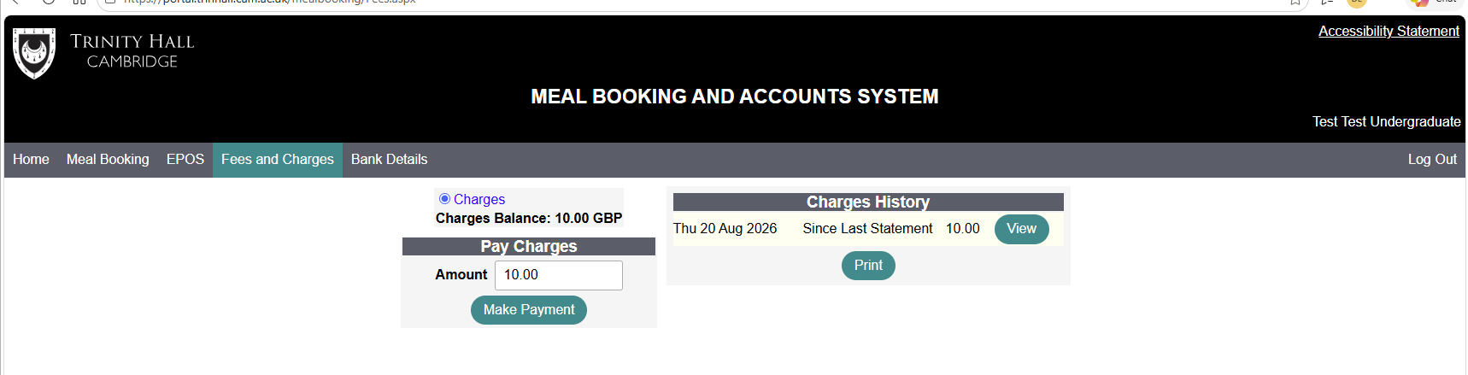

- Complete the payer information (if you are creating a payment link for someone else you must provide their details). Select “Pay Now” if you are making the payment or “Pay Later” to create a payment link to forward to the person making payment on your behalf.
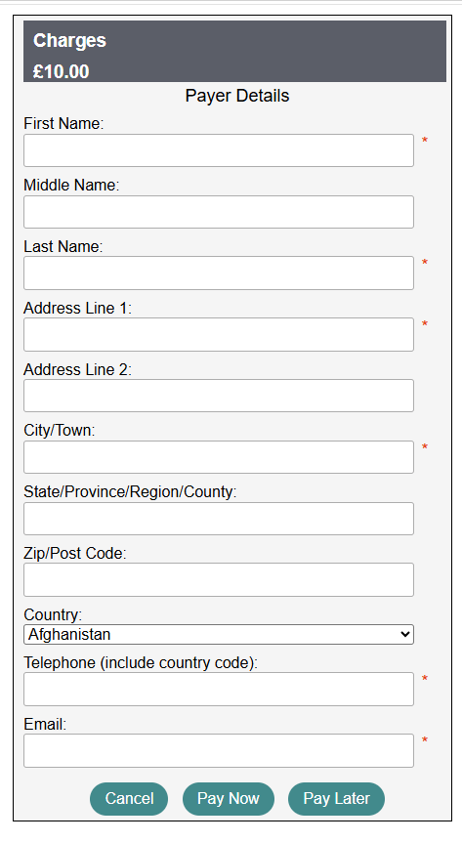

- The amount will automatically populate from the previous screen, select the country or region where your payment or payment wallet is based.

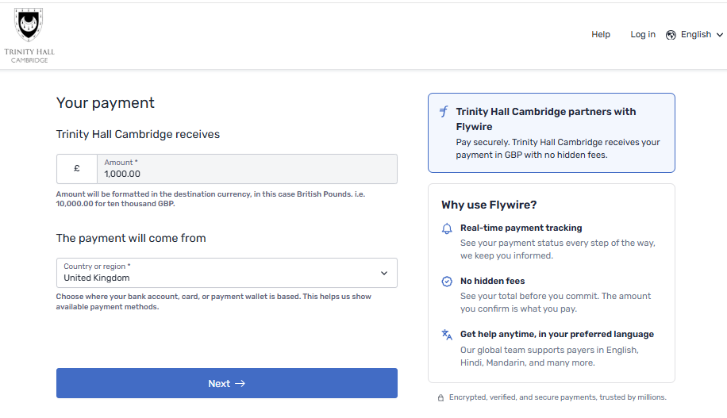

- Select your preferred currency; or choose “I want to pay in another currency” this may show further currency options. To make an immediate bank transfer from your UK bank account, select Trustly Online Bank Transfer. Then click “Select” and “Next”.

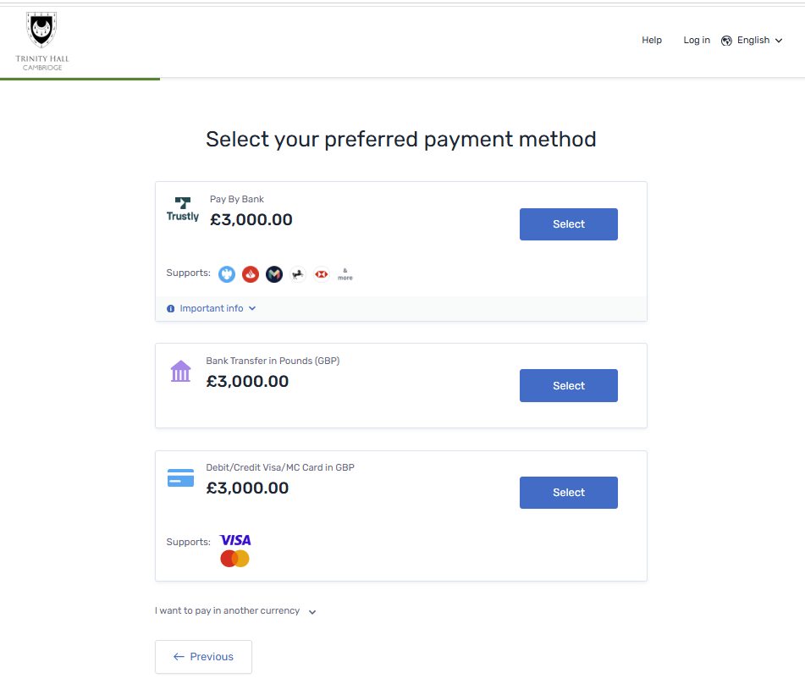

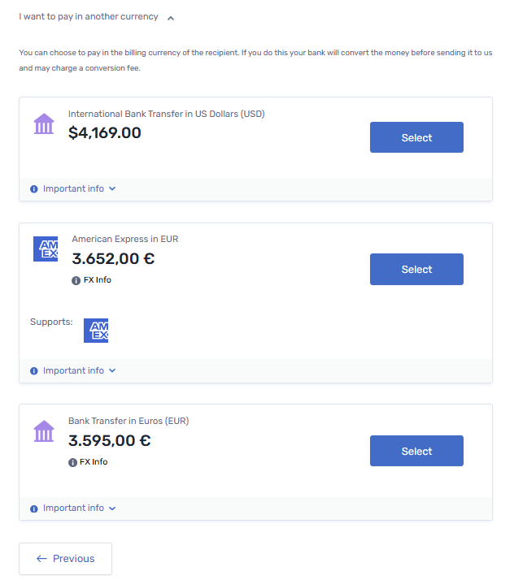
- The payer information will automatically populate from the previous screen. Accept the terms and conditions and select “Next”.

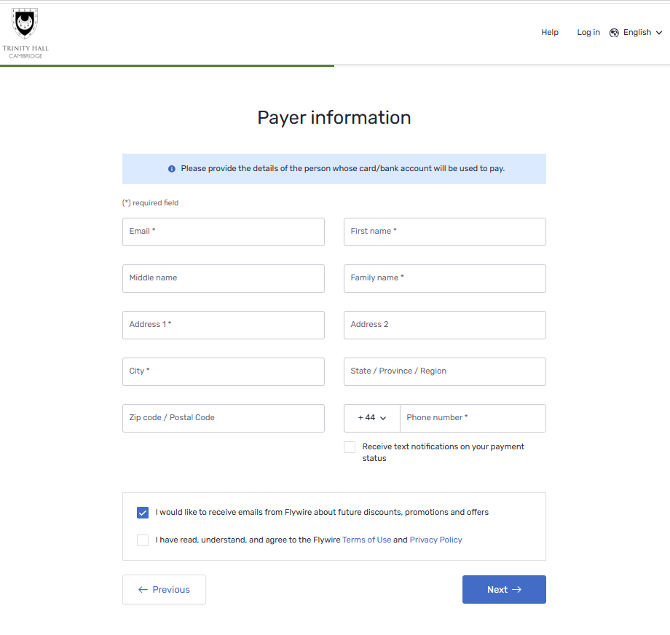
- Complete the Academic Information and add your email address under the Student Information heading then select “Next”.

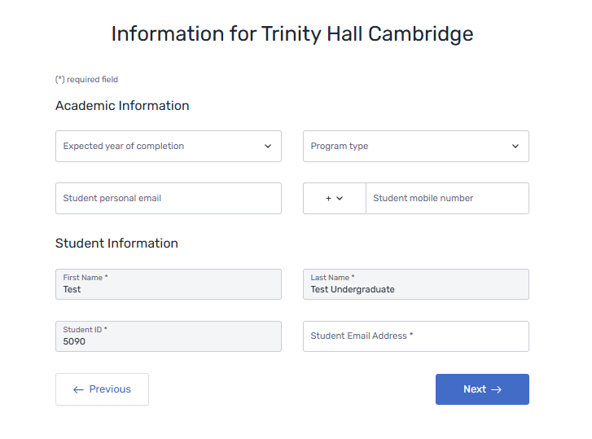
- Review your payment details and click “Next” to confirm.

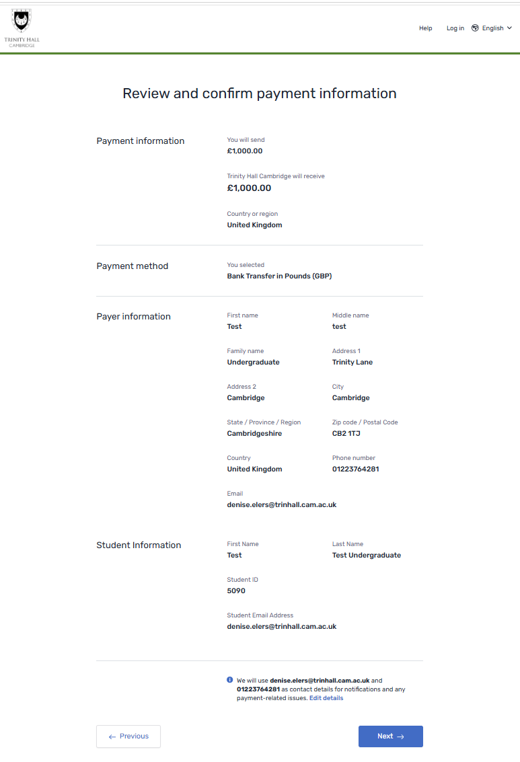

- Make payment to Flywire by either entering your card details or initiating a bank transfer. If paying by bank transfer, select “Download instructions for the bank transfer” to view the IBAN, Sort Code and Account Number for Flywire. If you wish to present this document to your bank, it can be downloaded and includes confirmation that Flywire is acting on behalf of the College. Do not use details from a previous payment request, as these may change. Please allow time for your confirmation of payment to arrive from Flywire, as this may not be immediate.

Flywire will transfer your payment to us once it has passed their validation checks. Please note that it can take up to 5 working days for us to receive your payment, which is due 14 days after you receive your bill.
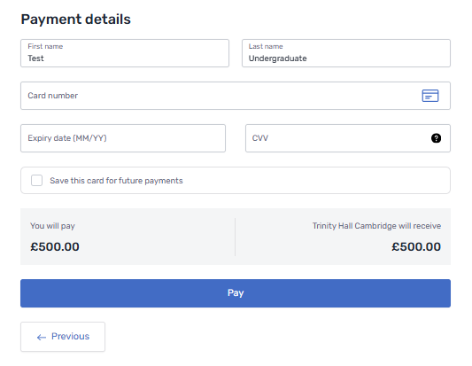
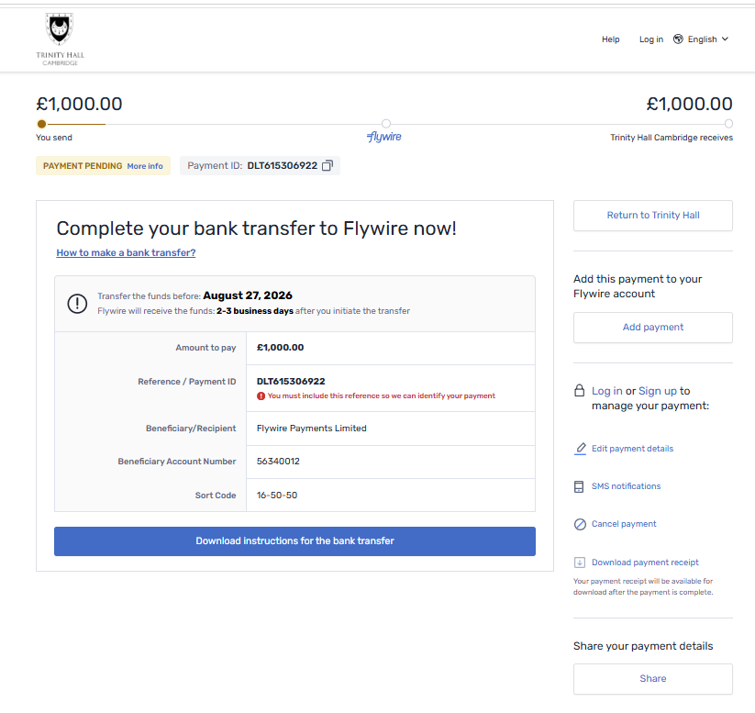
- Upon receipt of your payment by the College, Flywire will confirm the payment to the payer. You will also see your payment on your student account in the Fees and Charges tab on the Meal Booking and Accounts System.

Option 2 – Students/Graduands who do not have access to the Meal Booking and Accounts System should pay via the Flywire Open Portal.
- Open the Flywire Open Portal.

- Enter the amount you wish to pay and select the country the payment is coming from. It is important to select the country that your bank account or credit/debit card is registered in, then select “Next”.

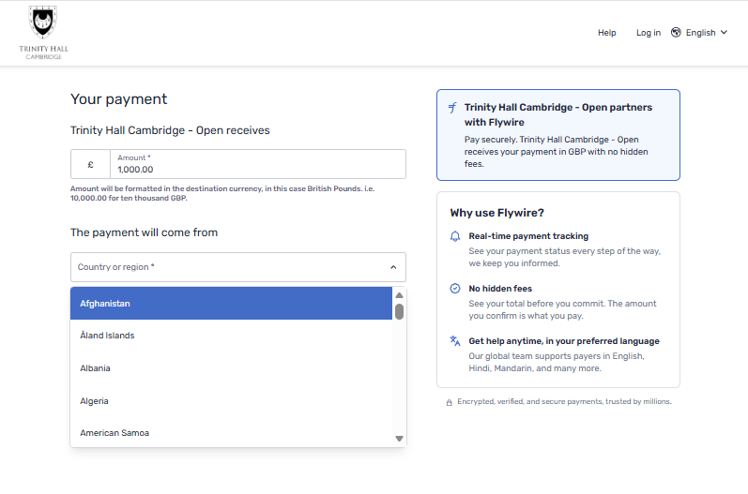
- You will now see the currency options available to you and if you select the link “I want to pay in another currency” this may show further currency options. You can make an immediate bank transfer from your UK bank account through Trustly Online Bank Transfer. Click on the “Select” button for your chosen currency and then select “Next”.

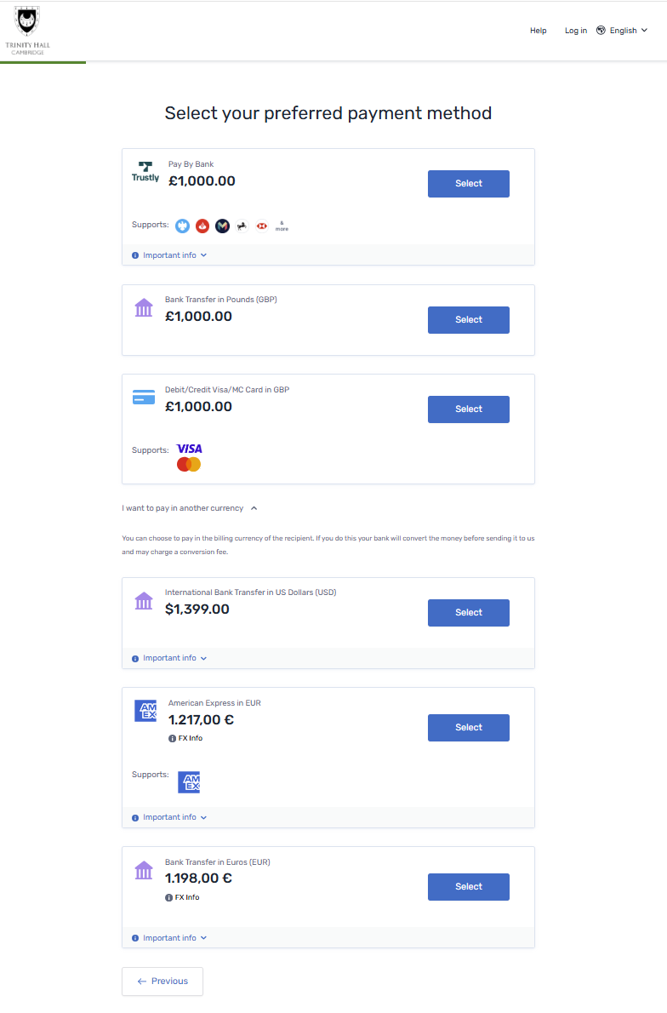
- Complete the payer information (if you are creating a payment link for someone else then provide their details):
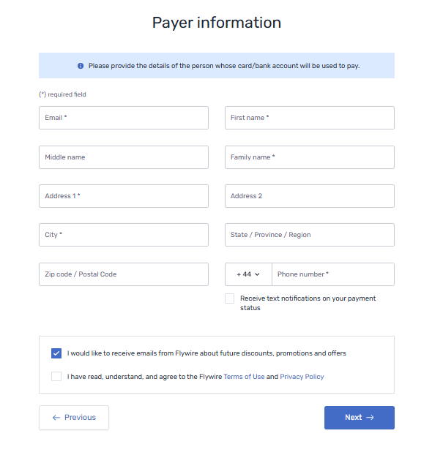
- Complete the Academic Information requested, please add a relevant CRSid in the field “student ID * or Event Reference*” so that the payment can be correctly allocated to your student account and select “Next”.

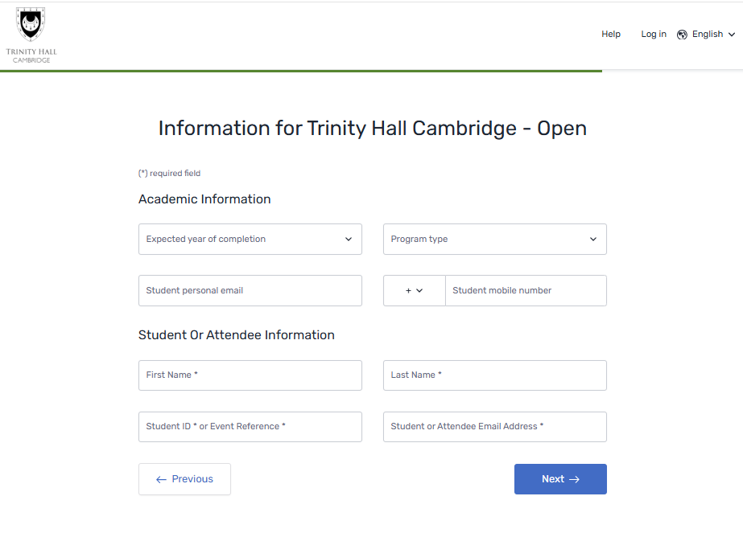

- Review and confirm your payment then select “Pay”.

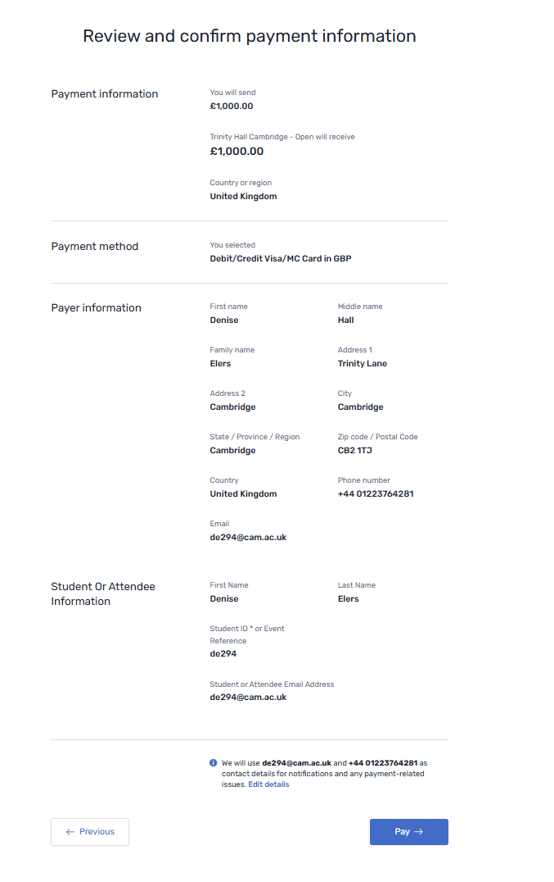
- Make payment to Flywire by either entering your card details or initiating a bank transfer. If paying by bank transfer, select “Download instructions for the bank transfer” to view the IBAN, Sort Code and Account Number for Flywire. If you wish to present this document to your bank, it can be downloaded and includes confirmation that Flywire is acting on behalf of the College. Do not use details from a previous payment request, as these may change. Please allow time for your confirmation of payment to arrive from Flywire, as this may not be immediate.

Flywire will transfer your payment to us once it has passed their validation checks. Please note that it can take up to 5 working days for us to receive your payment, which is due 14 days after you receive your bill.

- Upon receipt of the payment by the College, Flywire will email a receipt to the payer. You will also see your payment on your student account in the fees and charges tab on the Meal Booking and Accounts System.

